**Diverse collection of wild *Drosophila melanogaster* reveals the evolutionary history of a persistent viral infection**

**Alexandra H. Keene-Snickers1,2, Ali L. Brehm1 and Mark D. Stenglein1\***

1. Center for Vector-Borne and Infectious Diseases, Department of Microbiology, Immunology, and Pathology, College of Veterinary Medicine and Biomedical Sciences, Colorado State University, Fort Collins, CO, USA
2. Quantitative Cell and Molecular Biology Graduate Program

* Correspondence to: [Mark.Stenglein@colostate.edu](mailto:Mark.Stenglein@colostate.edu)

**ABSTRACT**

It is commonly understood that viruses, particularly RNA viruses, evolve at high rates. However, as more viruses are discovered it is evident that the study of viruses have been biased towards those of human, animal or plant health importance. Viral infections that can infect their host without appearing to cause any disease are being discovered. Yet, little is known about the biological and evolutionary roles these viruses play within their host and other microbiota. Evidence suggests that some of these viruses evolve at slower rates than other viruses, but their evolutionary patterns are not well known. Galbut virus, a ubiquitous, vertically transmitted and persistent viral infection of *Drosophila melanogaster* is an ideal model to study persistent virus evolution. Sequences were recovered from wild *D. melanogaster* collected from locations across the United States. These sequences were used to make phylogenetic trees to investigate the evolutionary patterns of a galbut virus infection. The trees revealed that galbut virus diversity is surprisingly low, even in populations that were intensely surveyed. Coinfection patterns showed that coinfection occurred in a segment independent manner and that the presence of infections from different genotypes was rare. There was evidence of reassortment between potentially extinct or incredibly rare galbut virus clades. The data collected here support that there are differences in viral evolution caused by the relationship the virus has with its host. This data suggests that some persistent viral infections are under less selective pressure than would be normally calculated providing evidence for a tight host-virus interface.

**INTRODUCTION**

The number of identified virus species is expanding at an exponential rate1–5. The virome of arthropods such as mosquitoes6–8, ticks9,10 and fruit flies11–13 have been characterized and are of particular interest for their human and animal health implications. Studies looking at some of these viruses’ basic biology have shown conflicting results on whether these viruses have an impact on the hosts health14,15. While other studies have focused on the role these viruses play in modulating the other microbiota in their host16–18. Overall, much is to be discovered to understand the role these viruses play from an evolutionary and biological perspective.

Galbut virus is a tri-segmented double-stranded (ds) RNA virus from the partitivirus family that infects *Drosophila melanogaster* and *Drosophila simulans*16,19. Chaq virus is either an optional fourth segment or satellite virus of galbut virus for which its role is yet to be identified12,19. Galbut virus appears to have limited impact on its hosts health. One study found that infection resulted in reduced offspring numbers15. Another found that it did not reduce offspring numbers but that it decreased the infected fly’s ability to fight fungal infections14. Galbut virus is globally distributed; every wild population examined thus far has some level of galbut virus prevalence. This is likely due to the ubiquitous nature of *D. melanogaster* in human environments20 and the mode of transmission from parent to offspring at near 100% efficiency19. It has been estimated that galbut virus has been infecting flies for at least 200 years12. The presence of a near complete endogenous viral element of the segment that encodes the RNA-dependent RNA polymerase and that it infects multiple hosts suggests that it has been infecting flies for much longer but there is not enough sequence data to calculate an accurate time to most recent common ancestor16,21.

Galbut virus appears to have an evolutionary rate that is lower than other dsRNA viruses. An observation that has been seen in other partitiviruses22,23. This is evidenced by the recent sequencing of *D. melanogaster* from museum collections resulting in sequences from a fly collected in 1908 that were nearly 99% identical to contemporary sequences, an estimate evolutionary rate of 6.43x10-5 24. For comparison, estimates of other dsRNA virus evolutionary rates are between 10-4 and 10-3 25. This slow evolutionary rate suggests that the evolutionary pressures on galbut virus are different than those of other dsRNA viruses. Its status as a persistent viral infection that is a result of generational passing down rather than an acute infection leading to a persistent infection could be a driver of the constrained substitution rates that have been reported. Understanding how these types of infections evolve may provide insights into an unexplored area of viral evolution.

To study persistent virus evolution, we obtained galbut virus sequences from *D. melanogaster* collected from diverse regions in the United States. We found that overall galbut virus diversity is low. We investigated the differences in genotypes and found that the presence of chaq virus is incredibly rare in genotype B infections, infections can result in high or low infection levels in genotype A and reassortment between genotypes is possible but uncommon. We found that coinfection of galbut virus occurs often and does not require all segments. Collectively, these data suggest that these types of infections are limited in their evolutionary movement due to the close interactions between the host and virus.

**RESULTS**

**Galbut virus clades A and B circulate within the same populations**

To understand the overall diversity of galbut virus infection in *D. melanogaster* we collected flies from eight locations in Larimer County, CO and one location each in Maine, Pennsylvania and Ohio (**Fig. 1A**). There were also samples collected from D. melanogaster colonized on peaches from a local grocery store. Since there is no way to know exactly where the flies started colonizing the fruit, these have been labeled as “unknown” (**Fig. 1**). Collections of flies in a Larimer County were done using buckets baited with banana and yeast. Flies collected from Maine, Pennsylvania and Ohio were carried out by volunteers using a previously designed 3D printed fly trap26. Volunteers were instructed to collect from these traps for as long as possible before sending the flies to our lab. During the collection period ~1000 flies were collected across all locations with most of the flies collected from Colorado.

RNA was extracted from individual flies, and each was screened for galbut virus via RT-qPCR. Two sets of primers were used to differentiate between galbut virus clade A and clade B (**Fig. 1B & 1C**). Ribosomal protein L32 was used to normalize galbut virus levels. Galbut virus clade A was the most abundant in all locations sampled. However, clade B was present in every population tested. In all locations except those with minimal sample sizes (Pennsylvania & Ohio) there were flies highly infected (Ct values > 20) and flies with low infection levels (Ct values < 25) (**Fig. 1B & 1C**). Different genotypes have been documented in wild caught populations maintained in our lab, but the effect of this difference biologically is still unknown [Tillie paper?].

Three locations were sampled over two or more months allowing us to limitedly look at galbut virus infection over time. Overall, galbut virus clade A was more abundant than clade B. However, the samples from the Center for Vector-borne Infectious Diseases (CVID) showed a shift in which clade was more abundant over time (**Fig. 1D**). In August, clade B was most prevalent with all, but two samples identified as clade B. In September, the prevalence of A increased to roughly the same as clade B. By October, the ratio of clade A to B had increased with only one sample identified as clade B. In the other two locations, clade A was dominant across all collection time points (**Fig. 1D**).

**Figure 1: Galbut virus clades A and B cocirculate among the same populations**. (A) Locations in the United States that wild *Drosophila* species were collected in 2023. Galbut virus positive screening of flies collected in Larimer County, CO (B) or in other regions of the United States (C). (D) Galbut virus infection over time in three locations of Larimer County, CO. RT-qPCR data is normalized to levels of RpL32 mRNA. Galbut virus genotype is denoted by shape and color.

**Galbut virus genotype A is associated with variable infectivity levels and chaq virus coinfection**

Of the roughly 1,000 samples collected, 155 were selected for downstream analysis via total RNA metagenomic sequencing. Samples were selected based on: 1) genotype- more B samples than A to increase representation of genotype B sequences; 2) samples that had high infection levels based on low ct values; and 3) samples that had low infection levels determined by high ct values (**Table 1**). Thirty-two of the sequenced samples did not contain enough galbut virus reads to generate any coding complete or near complete sequences. However, of the 123 remaining samples, 374 coding complete or near complete sequences were identified. Of the samples that yielded no galbut virus sequences, six were from Ohio and sequenced because they were not *D. melanogaster* but could have been infected by a virus similar to galbut virus, 22 were low positives, three were galbut virus genotype B and one was genotype A which was positive by only our genotype A detecting primers but not by the genotype A and B detecting primers.

We first wanted to compare the sequencing results with the RT-qPCR data. Samples identified as genotype A were represented the most across all sample locations. In fact, the RT-qPCR data suggested that Pennsylvania was represented solely by clade A (**Fig. 2**). When the sequences were placed into maximum likelihood trees, one Pennsylvania samples was more related to clade B (**Fig. 4, 5 & 6**). We also saw that most of the RT-qPCR low positive samples were also associated with genotype A, but that genotype A was represented evenly by low and high positive samples (**Fig. 2**). We were also interested in the association of chaq virus to galbut virus genotype A. In all but one case, the sequencing data revealed that chaq virus was associated with genotype A (**Fig. 2**).

**Table 1: Sequenced wild *D. melanogaster* metadata.**

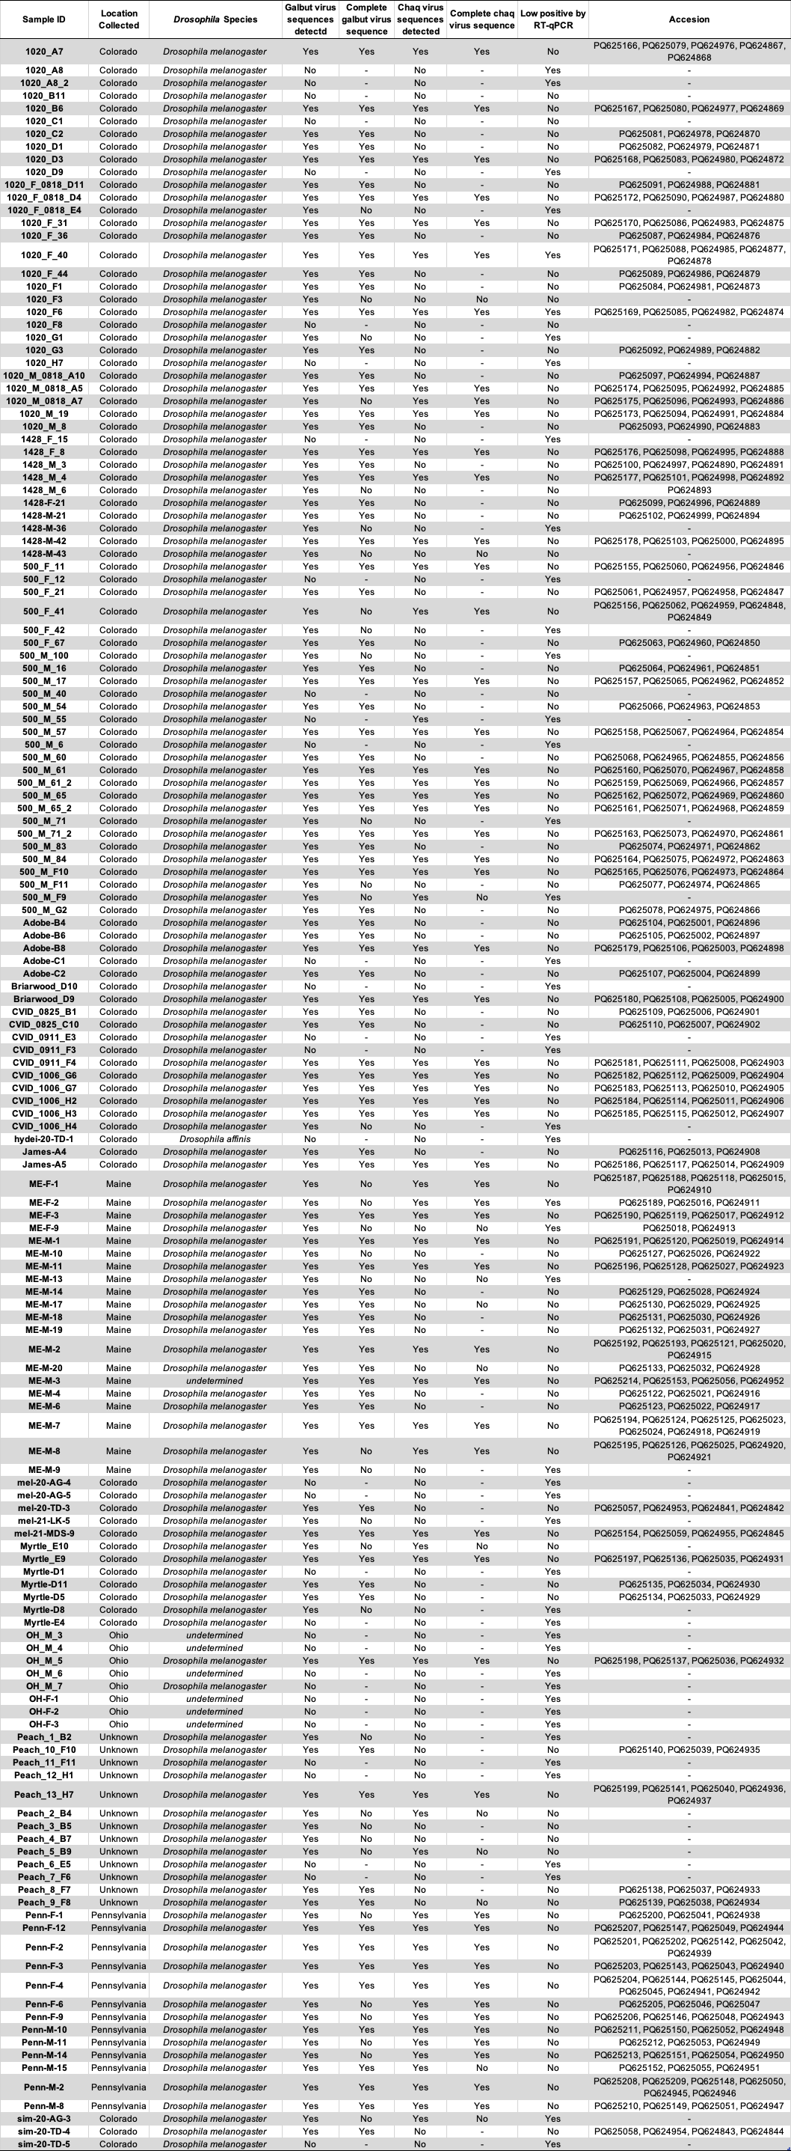



**Figure 2: High infectivity and presence of Chaq virus are associated with galbut virus clade A infection.** RT-qPCR data normalized to levels of RpL32 is shown for samples sequenced via total RNA metagenomics. Color denotes presence of Chaq-virus and shape denotes whether the sample was a low positive sample (ct > 25).

We next wanted to understand the distribution of galbut virus and chaq virus segments. We found that 41 samples had evidence of galbut virus or chaq virus coinfection. Thirty samples had evidence of more than one sequence in only one segment suggesting that coinfection can occur in a segment independent manner. The three samples that had complete coinfections of all three segments were the only samples with multiple RNA1 segments and neither of these samples had multiple chaq virus sequences (**Fig. 3**). Multiple RNA 3 segments was the most common, followed by RNA 2 and chaq virus (**Fig. 3**). One sample had evidence of coinfection by three RNA3 segments but only one of them was coding complete (**Fig. 3B**) and no samples from Colorado had coinfections of chaq virus (**Fig. 3A**). RNA 1 was the most common coding incomplete sequence with 13 samples missing evidence of an RNA 1 segment and 15 having only partial sequences (**Fig. 3**). For a heatmap containing sequence counts that were submitted to GenBank, please see **Supplemental Figure 1**.

**Figure 3: Coinfection of galbut virus does not require all three segments.** Heatmaps depicting the number of sequences associated with each segment. Boxes with an * indicate segments with one or more coding incomplete sequences. Samples are grouped by location (Colorado (A), Maine (B), Ohio (C), Pennsylvania (D) and unknown (E)).

**Supplemental Figure 1: Heatmap of sequences submitted to GenBank under the accession IDs: PQ624841- PQ625214**. Data as in Figure 3 except only samples with sequences submitted to GenBank are shown.

**Galbut virus diversity is low even within highly sampled populations**

We next wanted to investigate the similarity of galbut virus sequences across populations. We generated maximum likelihood phylogenetic trees using the galbut virus sequences generated here and those available through GenBank. To be included in the alignment, existing sequences had to derive from an individual specimen, have a known collection year and known collection location. We also generated galbut virus RNA 2 and 3 sequences from sequencing read archive (SRA) datasets for which galbut virus RNA 1 and Chaq virus sequences were already available16.

For all galbut virus segments and chaq virus overall diversity within and between populations was low (**Fig. 4, 5, 6 & 7**). Following previous data, galbut virus segments one and two indicate that there are three genotypes (**Fig. 4 & 5**)24. However, the addition of more galbut virus sequences revealed that there are two distinct subclades of clade A, we have termed these galbut virus clade A.1 and A.2 (**Fig. 6**). Chaq virus also consists of three clades (**Fig. 7**). Interestingly, galbut virus segments two and three showed that the *D. simulans* clade was related to galbut virus clade A while the *D. simulans* clade in segment one was related to clade B (**Fig. 4, 5, & 6**). The *D. simulans* clade of chaq virus was separate from all the *D. melanogaster* sequences (**Fig. 7**).

The distribution of sequences in these trees agreed with the RT-qPCR data as both clades co-circulated within the same populations. Additionally, clade A was more abundant than clade B. Even with an aim to enrich for clade B sequences, more clade A sequences were recovered (**Fig. 4, 5, & 6**).

There was some clustering by geographic location. For example, all the Pennsylvania samples cluster together (**Fig. 4, 5 & 6**). Similarly, the Australia samples cluster together except for a reassortant sample in RNA 1 (**Fig. 4, 5 & 6**). The Maine samples however were more diverse and were found throughout the trees (**Fig. 4, 5 & 6**). It is important to note that all locations fall within the Colorado samples which suggests that overall galbut diversity is low.

We next wanted to look at whether there was evidence for diversifying or purifying selection in galbut virus. Botella et al have reported that there was purifying selection in the RNA 1 and RNA 2 segments of one fungi infecting partitivirus27. We employed the Fixed Effects Likelihood model described by Kosakovsky-Pond and Frost to look for evidence of selection in each galbut virus segment and chaq virus28. There was little evidence of diversifying selection in galbut virus RNA 1, RNA 2 and chaq virus with two, two and four sites identified, respectively fro each segment (**Table 2**). However, galbut virus RNA 3 showed evidence of positive selection with 20 sites identified as undergoing diversifying selection (**Table 2**). For all segments and chaq virus there were more sites under purifying selection with 135, 58, 51, and 21 sites identified as purifying in galbut virus segments RNA 1, 2, 3 and chaq virus respectively.

**Figure 4: Midpoint rooted maximum likelihood phylogenetic tree of galbut virus RNA1.** Sample names are colored by location. Samples that were generated by different laboratories are indicated with an (*). Samples that were sequenced from old museum specimens are indicated by a (+). Support values are shown for select nodes. Accession numbers are noted except where groups of closely related sequences were collapsed.

**Figure 5: Midpoint rooted maximum likelihood phylogenetic tree of galbut virus RNA2.** Sample names are colored by location. Samples that were generated by different laboratories are indicated with an (*). Samples that were sequenced from old museum specimens are indicated by a (+). Support values are shown for select nodes. Accession numbers are noted except where groups of closely related sequences were collapsed.

**Figure 6: Midpoint rooted maximum likelihood phylogenetic tree of galbut virus RNA3.** Sample names are colored by location. Samples that were generated by different laboratories are indicated with an (*). Samples that were sequenced from old museum specimens are indicated by a (+). Support values are shown for select nodes. Accession numbers are noted except where groups of closely related sequences were collapsed.

**Figure 7: Midpoint rooted maximum likelihood phylogenetic tree of chaq virus.** Sample names are colored by location. Samples that were generated by different laboratories are indicated with an (*). Samples that were sequenced from old museum specimens are indicated by a (+). Support values are shown for select nodes. Accession numbers are noted except where groups of closely related sequences were collapsed.

**Table 2: Sites identified as diversifying selection.**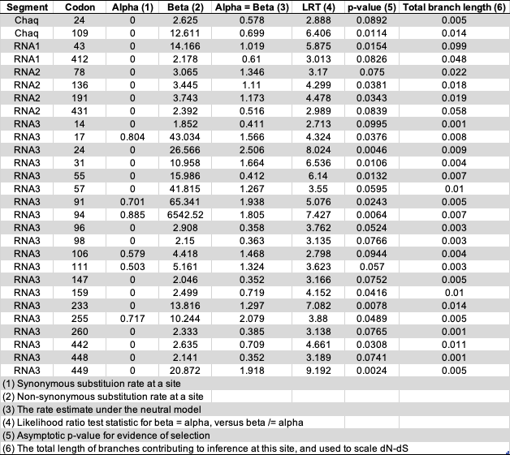

**Galbut virus low and high infection level is associated with genotype A but not B**

We were next curious whether there was a distribution in the number of reads mapping to galbut virus and chaq virus based on low or high infection status and the presence of chaq virus. In agreement with our RT-qPCR data (**Fig. 1B & 1C**), the number of reads per million (RPM) mapping to galbut virus showed that there were low and high levels of infection (**Fig. 8**). However, the number of reads mapping was not necessarily similar for each galbut virus segment in a sample. There are fewer chaq virus sequences associated with the low infection samples however, the distribution of high and low infection status was present in chaq virus genotype A (**Fig 8**).

In contrast to our RT-qPCR data, there was limited evidence of low and high infections in the genotype B samples. Overall, there were the fewest reads mapping to RNA 1 and the most mapping to RNA 3 (**Fig. 8**). Since chaq virus is rarely associated with genotype B we are unable to say whether the presence of chaq virus influenced the levels of galbut virus however, the one genotype B sample with chaq virus was one of the samples with more RPM (**Fig. 8**).

**Figure 8: Galbut virus genotype A is characterized by two distinct infection levels.** Reads per million total reads per sample are shown for chaq virus and each galbut virus segment. The y-axis is scaled by log10 and the plot is split into samples identified as genotype A or B. Points are colored and shaped by the presence of chaq virus.

**Galbut virus reassortment is more common between genotypes than across genotypes**

We next wanted to look for evidence of reassortment among galbut virus segments and between galbut virus and chaq virus. We generated tanglegrams of all possible combinations of galbut virus and galbut virus and chaq virus.

There is some evidence of reassortment among galbut virus segments. One sample collected from Colorado in 2023 (2023 500-M-61-2) is classified as genotype A in all segments but RNAs 1 and 2 are on an isolated branch within A while RNA 3 is in clade A.1 (**Fig. 9, 10 & 11**). Another sample collected in the same location (2023 500-M-60) has two RNA 3 segments, one of each genotype while the RNA 1 and 2 segments indicate no partial segments and fall within genotype B (**Fig. 9, 10 & 11**). Within genotypes there is evidence of more diversity. For example, galbut virus RNA 2 of a 2023 Colorado sample (500-F-67) is clustered with Pennsylvania samples but in RNA 3 it is more similar to several samples from Maine and Colorado (**Fig. 9, 10 & 11**).

It was extremely rare for a galbut virus genotype B to also have chaq virus. There were five exceptions to this shown in our tanglegrams. Two were samples with complete galbut virus coinfections of genotypes A and B (ME-M-7 & Penn-F-4); it is likely that the chaq virus associated with these samples is part of the clade A sequences (**Fig. 12, 13 & 14**). The third exception to this is a Pennsylvania sample (Penn-F-6) with two RNA 2 sequences one of each genotype but no RNA 1 or 3 coding complete sequences (**Fig. 13**). The only exception that appears to be a true chaq virus infection of a galbut virus B genotype is a sample from Maine that had two chaq virus sequences but galbut virus sequences that fall within genotype B. The chaq virus sequences associated with this sample are part of different chaq virus clades (**Fig. 12, 13 & 14**).

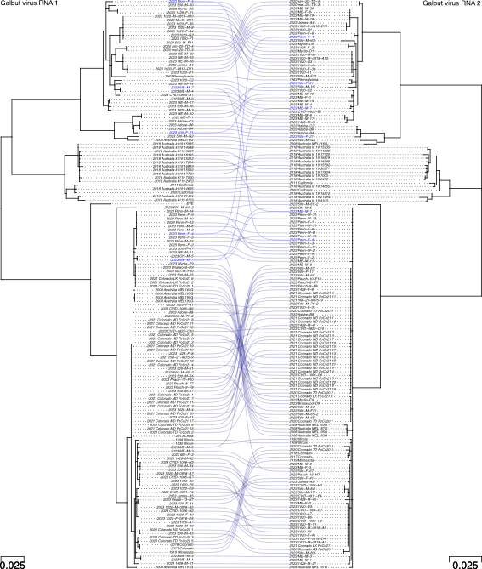

**Figure 9: Co-phylogeny of galbut virus RNA1 and RNA 2.** Branches with support values < 0.001 were converted to polytomies prior to generation of the phylogeny. Trees were midpoint rooted. Sample names and lines are colored by coinfection status.

**Figure 10:** **Co-phylogeny of galbut virus RNA1 and RNA 3.** Branches with support values < 0.001 were converted to polytomies prior to generation of the phylogeny. Trees were midpoint rooted. Sample names and lines are colored by coinfection status.

**Figure 11:** **Co-phylogeny of galbut virus RNA 2 and RNA 3.** Branches with support values < 0.001 were converted to polytomies prior to generation of the phylogeny. Trees were midpoint rooted. Sample names and lines are colored by coinfection status.

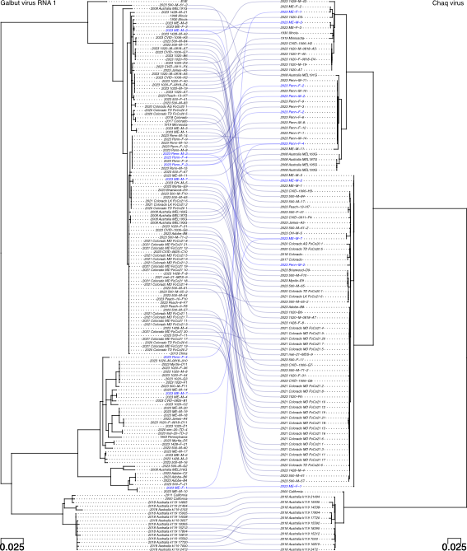

**Figure 12:** **Co-phylogeny of galbut virus RNA1 and chaq virus.** Branches with support values < 0.001 were converted to polytomies prior to generation of the phylogeny. Trees were midpoint rooted. Sample names and lines are colored by coinfection status.

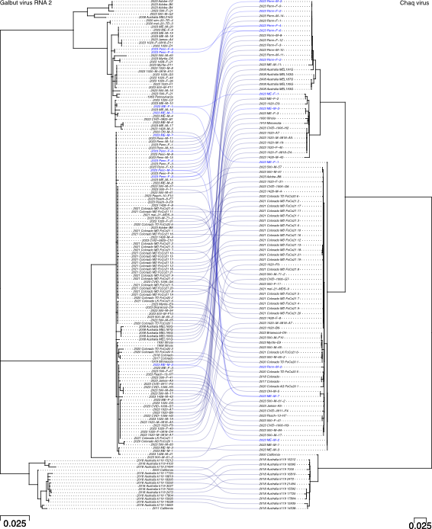

**Figure 13:** **Co-phylogeny of galbut virus RNA 2 and chaq virus.** Branches with support values < 0.001 were converted to polytomies prior to generation of the phylogeny. Trees were midpoint rooted. Sample names and lines are colored by coinfection status.

**Figure 14:** **Co-phylogeny of galbut virus RNA 3 and chaq virus.** Branches with support values < 0.001 were converted to polytomies prior to generation of the phylogeny. Trees were midpoint rooted. Sample names and lines are colored by coinfection status.

**DICUSSION**

In this manuscript we sought to understand the evolutionary patterns of galbut virus, a persistent and ubiquitous viral infection of *D. melanogaster*12. Flies from Colorado, Pennsylvania, Maine, Ohio and an unknown location were screened for galbut virus. The RT-qPCR data showed that genotypes A and B cocirculate within populations, genotype B was less common than genotype A and flies could be infected at low or high levels (**Fig. 1**). One-hundred and fifty-five samples were selected for shotgun metagenomics. Most of the samples had coding complete or near complete galbut virus sequences that in combination with other available sequences were used to investigate galbut virus diversity and evolution.

We found that overall galbut virus sequence diversity is low. One way to explain this is by looking at the factors that allow a virus to maintain itself in a population. Highly studied persistent viral infections are generally acute infections that become persistent29–31. In the case of galbut virus, these viruses are transmitted vertically and are infections that occur over the lifetime of the host32,33. This close association between virus and host means that the pressures on galbut virus are different than persistent infections that only last the life of the host. The prisoner of war hypothesis is one way to understand this interaction34. Constraints have been placed on how much galbut virus can evolve due to its close relationship with the host. If the virus mutates in a way that harms *D. melanogaster’s* ability to pass the virus to its offspring, then it will be detrimental to the virus. Similarly, if the virus becomes pathogenic, then the fly’s fitness will decrease, and the virus will not be transmitted to the next generation.

We explored the potential of using time resolved phylogenetic methods to predict how long galbut virus has been infecting flies, when galbut virus jumped between hosts and to estimate the evolutionary rate. Even with 100+ sequences from diverse locations and sequences over 110-years-old, there was not enough diverity to identify a time signal when we tested with TempEst35. Galbut virus is simply not evolving fast enough to use tools like BEAST to estimate a time to most recent common ancestor36. We therefore generated maximum likelihood trees to explore the phylogenetic structure of galbut virus and chaq virus.

The overall structure of our trees were similar to a previous study24. Three clades of galbut virus were detected: clade A and B and a *D. simulans* clade. Our trees revealed that clade A of RNA 3 has two sub-clades: clade A.1 and A.2. The *D. simulans* clade was more closely related to clade B for RNA 1 and clade A for RNA 2 and 3 (**Fig. 4-7**). This suggests that *D. simulans* galbut virus is a reassortant of genotypes A and B37. How a host jump with a vertically transmitted virus would occur is unclear. Perhaps there is more successful inbreeding in the wild than thought38. There is limited evidence of geographic structure in our trees. All clade A sequences from Pennsylvania were highly similar while Maine sequences were dispersed throughout the tree. Sequences from diverse locations except for Australia were found within Colorado sequences (**Fig. 4-7**). The distinction between United States of America samples and Australia samples is likely due to the massive geographic distance between the two countries39.

The availability of sequences over time is limited. Sequences that were identified recently from specimens stored in museums showed surprising similarity to contemporary sequences24. The addition of more sequences confirms that even within highly sampled populations, diversity is low. These data are supported by the limited evidence of diversifying selection in galbut virus and chaq virus (**Table 2**). Galbut virus RNA 3 was the only segment to show evidence of selection which likely has to do with its unknown role. Perhaps RNA 3 is involved in the RNA interference response and host immune modualtion40,41.

The sequences identified in this study enabled us to investigate the differences in A/B genotypes and the presence of chaq virus. We confirmed that chaq virus infection with clade B galbut virus was extremely rare. ME-F-1 was the only clade B sample associated with chaq virus infection (**Fig. 9-14**). There are low- and high- infection levels associated with galbut virus infection but how it is implicated in clade A or B infection and whether chaq virus presence factors in was unknown. When we normalized the number of reads per segment by the total number of reads the high and low pattern was true for clade A infections but not for clade B infections (**Fig. 8**). Chaq virus infection was found in low- and high-level infections (**Fig. 8**). Therefore, it appears that chaq virus does not impact levels of galbut virus infection.

The biology of galbut virus coinfection is complex. Galbut virus coinfection does not require all segments. Forty-one samples had evidence of coinfection. Seventeen had a coding complete second sequence of at least one galbut virus segment or chaq virus segment (**Fig. 3**). Only two samples had complete coinfections. In both cases, these represented coinfections from each clade. Galbut virus RNA 3 represented the most coinfections while RNA 1 represented the fewest (**Fig. 3**). It is possible the role RNA 3 plays makes it more permissive to coinfection than RNA 1 or that RNA 1 is not specific to the transcripts it copies. Coinfection of one segment from each clade was also present. Samples 500-M-60 and Penn-M-2 had coding complete sequences from each clade in RNA 3 (**Fig. 3 & 6**).

There is limited evidence of reassortment across genotypes. In all cases of potential reassortment between genotypes, there was coinfection of both clades (**Fig. 9-14**). Infections like this do suggest that replication of segments does not require all sequences to be from the same genotype. There is evidence of within genotype reassortment. RNA 1 and 2 of sample 500-M-61-2 and MEL191G from Australia, are on divergent branches within clade A but the RNA 3 sequences are similar to other RNA 3 sequences. When we investigated recombination, all recombination events identified by the RDP were explained as unaccounted-for low-level coinfection or the result of fluctuation in similarity by chance42.

To understand galbut virus infection in other *drosophila* species, particularly *D. simulans*, we used a nextflow based Sequence Read Archive mining strategy, but we were only able to recover galbut virus RNA 2 and 3 sequences for the RNA 1 and chaq virus sequences already available16. An effort to capture and sequence *D. simulans* from diverse regions would expand our knowledge of galbut virus evolution within this species and across species.

The study of how persistent viral infections evolve will continue to grow. As more sequences are deposited, the complex interactions that lead to lifelong infection of seemingly non-pathogenic viruses will be elucidated. This study has answered questions about the evolutionary trajectory of a common persistent viral infection of *D. melanogaster*. Studies like these will benefit from subsequential wet lab experiments to further investigate the biology of persistent virus evolution. There is strong evidence that these infections do not evolve in a way that is expected. More studies investigating these types of infections will be needed to further support these findings.

**MATERIALS AND METHODS**

*Sample Collection:* Flies were collected over the summer of 2023 from Maine, Pennsylvania, Ohio, Colorado. Roughly 1000 flies were collected. Flies collected in Colorado were trapped in buckets baited with banana and yeast with organdy mesh (Oriole Textile, 2060) on top of the decaying fruit. Flies captured in Maine, Pennsylvania and Ohio were trapped using a 3D printed fly trap26. The flies of unknown origin were isolated from peaches bought at a grocery store in Fort Collins, CO, although the peaches were from California, we were unable to definitively determine where they came from.

*RNA Extraction:* RNA was extracted from individual flies using a magnetic bead-based RNA/DNA capture method modified for use on the KingFisher (ThermoFisher Scientific). Briefly, flies were placed in an assay block (ThermoFisher Scientific, 9761116) with a small BB (McMaster Carr, 1598K22) and 100µL lysis buffer (1M DTT (added fresh), 5M guanidine thiocyanate, 0.1M Tris-HCl (pH 7.5), 0.01M Na2EDTA (pH8.0)). Flies were homogenized at 30 Hz for three minutes in a TissueLyszer II (Qiagen). The homogenate was moved to a new deep well plate (Thermofisher, 9504050) and combined with a mastermix that included: 90µL homemade DNA/RNA magnetic beads (1.0 mL SpeedBeads (Cytiva, 65152105050250) in 1.0 mL TE (10mM Tris-HCl, 1mM EDTA) mixed in a 50 mL conical with 9.0g PEG-8000, 10 mL 5M NaCl, 500 μL 1M Tris-HCl, 100 μL 0.5M EDTA and 27.5 μL Tween 20 brought to 50 mL with sterile dH2O), 10µL lysis binding enhancer (Proteinase K 200 μg/mL, 20% glycerol, 0.5% SDS) and 60µL 100% isopropanol. In separate 96 well standard plates (ThermoFisher, 97002540), 150µL of wash buffer one (20% Ethanol, 900 mM guanidine thiocyanate, 10 mM Tris-HCl (pH 7.5)), wash buffer two (1X TE, 80% Ethanol) and 50µL of sterile water was added. The extraction was completed using a custom protocol for the KingFisher. Eluted nucleic acids were then stored at -80°C until needed.

*Galbut virus positivity:* To determine which samples were positive for galbut virus, cDNA was generated using 5.5µL RNA, 10µM random hexamer primers (IDT), 10µM dNTPs and water to 13µL and incubated at 65°C for 5 minutes. Next, 4µL 5X FS buffer, 1µL 0.1M DTT and 1µL reverse transcriptase was added and incubated at 50°C for 60 minutes followed by a heat inactivation step at 80°C for 10 minutes after which each sample was diluted in 90µL nuclease-free water. qPCR was conducted using NEB Luna Universal qPCR Mastermix following manufacturer recommendations and cycling conditions (NEB, M3003). Of the 1000 flies captured, 952 were positive for RpL32, suggesting a successful extraction and 641 were positive for galbut virus. Each sample was screened for galbut virus using two primer sets (**Table 3**).

|  |  |  |  |
| --- | --- | --- | --- |
| Primer pair name (#s in lab collection) | Forward | Reverse | Reference |
| Galbut virus 1 (#1600/1601) | CCGTGAAGCAAGGAATCAAT | TGCCGATTTTCTGCTCTTTT | Cross 202019 |
| Galbut virus 2  (#2165/2170) | GTTCTTATCCGCATCGCCTA | AATTCACTACTTCCTTGACACCTC | This study |
| RpL32- long (1012/1013) | TGCTAAGCTGTCGCACAAATGG | TGCGCTTGTTCGATCCGTAAC | Cao 201643 |

*NGS Library Preparation:* Of the 641 galbut virus positive samples, 155 were selected for NGS total RNA sequencing. Samples were selected based on their location (novel location), the degree of positivity (a range of high to low positive) and proximity to the positive control melting temperature (very similar to nearly a degree away). Sample concentration was obtained using the Qubit high-sensitivity RNA reagent (ThermoFisher, Q32852) and DNA was removed via a DNAse I treatment (NEB B0303S). Prior to library preparation, samples were normalized to 5 ng/µL except where sample concentration was too low. In these cases, either a different sample was selected or the maximum volume of input RNA was used. Due to limited availability of barcodes in our lab, the samples were split into two groups. Samples were prepared for sequencing using the Kapa Biosystems Kapa RNA Hyper Prep kit following manufacturer recommendations (Roche, 08098093702). Eight cycles were used for library amplification. HeLa cell RNA was used as a positive control and water was used as a negative control for both library preparations and sequencing. Sample pooling was determined using High Sensitivity DNA Qubit reagents and final library quality control was done using an Agilent D1000 HS Tapestation and KapaQuant reagents following manufacturers recommendations (Roche, 07960140001). Both pools were sent to Azenta/Genewiz where they were sequenced on a NovaSeq with 2X150 paired end sequencing.

**Data Analysis**

*Identification of virus sequences:* We used our lab’s previously described metagenomic classification pipeline (<https://github.com/stenglein-lab/taxonomy_pipeline>) to identify and validate virus sequences in the NGS datasets. In brief, adapters and low-quality reads were trimmed using cutadapt 3.544. Fastqc 0.11.945 was used to assess post-collapsed read quality. Host reads were removed using bowtie2 2.4.546 and the remaining reads were assembled using spades 3.15.447. Virus sequences were identified using BLASTn 2.12.0. Draft sequences were validated by remapping of trimmed reads using bwa mem aligner version 0.7.1748. Final sequences were submitted to the NCBI nucleotide database and raw NGS data to the NCBI sequence read archive repository.

*Molecular species identification:* To confirm the species identification of the samples, we used our labs species identification pipeline (<https://github.com/stenglein-lab/species_id>)24. In brief, this pipeline takes preprocessed reads and maps them to a given set of sequences. For our purposes we used a set of 529 cytochrome c oxidase sequences from Drosophilidae. This pipeline identified one *Drosophila affinis*, one *Drosophila simulans* and 147 *D. melanogaster*. Six samples remained undetermined.

*Maximum Likelihood trees:* All available galbut virus and chaq virus sequences with a known location, date of collection and were from individual flies were downloaded from GenBank. Alignments were generated using MAFFTT v7.490 with default parameters49. IqTree v2.3.6 was used to generate maximum likelihood trees50. A bash script utilizing the IqTree singularity container were used to run the tree analysis. The parameters used were: substitution model- auto, alrt- 1000, bootstrap- 1000 and mem- 33%. iTol was used for tree visualization51. Trees were midpoint rooted.

Positive selection analysis: We used the Fixed Effects Likelihood model described by Kosakovsk-Pond and Frost28. This analysis was run on Datamonkey with the HyPhy application52,53. We explored the FUBAR method (fast, unconstrained Bayesian approximation) and had similar results for galbut virus RNAs 1 and 2 and chaq virus however considerably less sites of positive selection were identified in RNA 354. Given that sequences in the RNA 3 alignment are as low as % like other sequences, the data from the FEL method made more sense.

*Recombinant detection analysis:* We performed recombination detection analysis using the Recombination Detection Program42,55 which identified one candidate recombination event in chaq virus and another in galbut virus RNA 3. We used a custom script using Bio-python and R to count and then visualize the percent identity between the candidate recombination events. This visualization led us to conclude that the chaq virus recombinant was the result of a chimera. The galbut virus RNA 3 recombination event was not convincing.

*Cophylogeny analysis*: Tanglegrams were generated in R/RStudio using the phytools and ape packages56,57. Branches shorter than 0.001 were turned into polytomies to make visualization of the trees easier.

**ACKNOWLEDGEMENTS**

The authors would like to acknowledge the individuals that volunteered to collect wild flies: Lisa Harrington and Paul Keene, Khwannarin Khemsom, Anastazia Jablumovsky, Elle Irons and Michael Martzahn, Kelly Wallace and Ben Ryan, Claire Stewart and Natali Wickencamp [NEW BELGIUM????]. We thank them for their effort in collecting flies themselves or for the opportunity for us to collect flies from their property.

**FUNDING**

NSF IOS 2048214 (AHK, ALB and MDS) and NIH T32GM132057 (AHK)

**REFERENCES**

1. Qi, Y. H., Ye, Z. X., Zhang, C. X., Chen, J. P. & Li, J. M. Diversity of RNA viruses in agricultural insects. *Computational and Structural Biotechnology Journal* vol. 21 4312–4321 Preprint at https://doi.org/10.1016/j.csbj.2023.08.036 (2023).

2. Neri, U. *et al.* Expansion of the global RNA virome reveals diverse clades of bacteriophages. *Cell* **185**, 4023-4037.e18 (2022).

3. Shi, M. *et al.* Redefining the invertebrate RNA virosphere. *Nature* **540**, 539–543 (2016).

4. Chen, Y.-M. *et al.* RNA viromes from terrestrial sites across China expand environmental viral diversity. *Nat Microbiol* **7**, 1312–1323 (2022).

5. Jian, H. *et al.* Diversity and distribution of viruses inhabiting the deepest ocean on Earth. *ISME J* **15**, 3094–3110 (2021).

6. Shi, C. *et al.* Stable distinct core eukaryotic viromes in different mosquito species from Guadeloupe, using single mosquito viral metagenomics. *Microbiome* **7**, 121 (2019).

7. Ternovoi, V. A. *et al.* The Viromes of Mosquitoes from the Natural Landscapes of Western Siberia. *Viruses* **15**, (2023).

8. Coatsworth, H. *et al.* Intrinsic variation in the vertically transmitted core virome of the mosquito *Aedes aegypti*. *Mol Ecol* (2022) doi:10.1111/mec.16412.

9. Harvey, E. *et al.* Extensive Diversity of RNA Viruses in Australian Ticks. *J Virol* **93**, (2019).

10. Oluwayelu, D. O., Karim, S., Du, J. & Sun, Y. *Diversity of RNA Viruses of Three Dominant Tick Species in North China*. www.ncbi.nlm.nih.gov/Structure/cdd/wrpsb.cgi.

11. Kuyateh, O. & Obbard, D. J. Viruses in Laboratory Drosophila and Their Impact on Host Gene Expression. *Viruses* **15**, 1849 (2023).

12. Webster, C. L. *et al.* The Discovery, Distribution, and Evolution of Viruses Associated with Drosophila melanogaster. *PLoS Biol* **13**, e1002210 (2015).

13. Palmer, W. H., Medd, N. C., Beard, P. M. & Obbard, D. J. Isolation of a natural DNA virus of Drosophila melanogaster, and characterisation of host resistance and immune responses. *PLoS Pathog* **14**, (2018).

14. Cross, S. T. *et al.* Galbut Virus Infection Minimally Influences Drosophila melanogaster Fitness Traits in a Strain and Sex-Dependent Manner. *Viruses* **15**, 539 (2023).

15. Wallace, M. A. & Obbard, D. J. Naturally occurring viruses of *Drosophila* reduce offspring number and lifespan. *Proceedings of the Royal Society B: Biological Sciences* **291**, (2024).

16. Ortiz-Baez, A. S., Shi, M., Hoffmann, A. A. & Holmes, E. C. RNA virome diversity and Wolbachia infection in individual Drosophila simulans flies. *J Gen Virol* **102**, 001639 (2021).

17. Martinez, J. *et al.* Symbionts Commonly Provide Broad Spectrum Resistance to Viruses in Insects: A Comparative Analysis of Wolbachia Strains. *PLoS Pathog* **10**, (2014).

18. Shi, M. *et al.* No detectable effect of Wolbachia wMel on the prevalence and abundance of the RNA virome of Drosophila melanogaster. *Proceedings of the Royal Society B: Biological Sciences* **285**, (2018).

19. Cross, S. T. *et al.* Partitiviruses Infecting Drosophila melanogaster and Aedes aegypti Exhibit Efficient Biparental Vertical Transmission. *J Virol* **94**, (2020).

20. Keller, A. Drosophila melanogaster’s history as a human commensal. *Current Biology* **17**, PR77-R81 (2007).

21. Wallace, M. A. *et al.* The discovery, distribution, and diversity of DNA viruses associated with *Drosophila melanogaster* in Europe. *Virus Evol* **7**, veab031 (2021).

22. Thapa, V. *et al.* Using a Novel Partitivirus in Pseudogymnoascus destructans to Understand the Epidemiology of White-Nose Syndrome. *PLoS Pathog* **12**, e1006076 (2016).

23. Jiang, Y. *et al.* Prevalence and diversity of mycoviruses infecting the plant pathogen Ustilaginoidea virens. *Virus Res* **195**, 47–56 (2015).

24. Keene, A. H. & Stenglein, M. D. Sequencing RNA from old, dried specimens reveals past viromes and properties of long-surviving RNA. Preprint at https://doi.org/10.1101/2024.10.03.616531 (2024).

25. Peck, K. M. & Lauring, A. S. Complexities of Viral Mutation Rates. (2018) doi:10.1128/JVI.

26. Keene-Snickers, A. H., Dunham, T. J. & Stenglein, M. D. Experimental assessment of 3D-printed traps and chemical attractants for the collection of wild Drosophila melanogaster. Preprint at https://doi.org/10.1101/2025.01.28.635319 (2025).

27. Botella, L., Vainio, E. J., Hantula, J., Diez, J. J. & Jankovsky, L. Description and prevalence of a putative novel mycovirus within the conifer pathogen Gremmeniella abietina. *Arch Virol* **160**, 1967–1975 (2015).

28. Kosakovsky Pond, S. L. & Frost, S. D. W. Not So Different After All: A Comparison of Methods for Detecting Amino Acid Sites Under Selection. *Mol Biol Evol* **22**, 1208–1222 (2005).

29. Boldogh, I., Albrecht, T. & Porter, D. D. *Persistent Viral Infections*. (Galveston, TX, 1996).

30. Sullivan, B. M., Teijaro, J. R., de la Torre, J. C. & Oldstone, M. B. A. Early Virus-Host Interactions Dictate the Course of a Persistent Infection. *PLoS Pathog* **11**, 1–14 (2015).

31. Hilleman, M. R. Strategies and mechanisms for host and pathogen survival in acute and persistent viral infections. *Proceedings of the National Academy of Sciences* **101**, 14560–14566 (2004).

32. Nibert, M. L. *et al.* Taxonomic reorganization of family Partitiviridae and other recent progress in partitivirus research. *Virus Res* **188**, 128–41 (2014).

33. Ghabrial, S. A., Ochoa, W. F., Baker, T. S. & Nibert, M. L. Partitiviruses: General Features. in *Encyclopedia of Virology (Third Edition)* (eds. Mahy, B. W. J. & Van Regenmortel, M. H. V) 68–75 (Academic Press, Oxford, 2008). doi:https://doi.org/10.1016/B978-012374410-4.00573-2.

34. Simmonds, P., Aiewsakun, P. & Katzourakis, A. Prisoners of war — host adaptation and its constraints on virus evolution. *Nat Rev Microbiol* **17**, 321–328 (2019).

35. Rambaut, A., Lam, T. T., Max Carvalho, L. & Pybus, O. G. Exploring the temporal structure of heterochronous sequences using TempEst (formerly Path-O-Gen). *Virus Evol* **2**, vew007 (2016).

36. Suchard, M. A. *et al.* Bayesian phylogenetic and phylodynamic data integration using BEAST 1.10. *Virus Evol* **4**, (2018).

37. ALEXANDER, D. J. & BROWN, I. H. Recent zoonoses caused by influenza A viruses. *Revue Scientifique et Technique de l’OIE* **19**, 197–225 (2000).

38. CASTLE, W. E. INBREEDING, CROSS-BREEDING AND STERILITY IN DROSOPHILA. *Science (1979)* **23**, 153–153 (1906).

39. Kolodziejek, J. *et al.* Genetic clustering of Borna disease virus natural animal isolates, laboratory and vaccine strains strongly reflects their regional geographical origin. *Journal of General Virology* **86**, 385–398 (2005).

40. Swevers, L., Broeck, J. Vanden & Smagghe, G. The possible impact of persistent virus infection on the function of the RNAi machinery in insects: A hypothesis. *Front Physiol* **4 NOV**, (2013).

41. Karlikow, M., Goic, B. & Saleh, M. C. RNAi and antiviral defense in Drosophila: Setting up a systemic immune response. *Dev Comp Immunol* **42**, 85–92 (2014).

42. Martin, D. & Rybicki, E. RDP: detection of recombination amongst aligned sequences. *Bioinformatics* **16**, 562–563 (2000).

43. Cao, C., Magwire, M. M., Bayer, F. & Jiggins, F. M. A Polymorphism in the Processing Body Component Ge-1 Controls Resistance to a Naturally Occurring Rhabdovirus in Drosophila. *PLoS Pathog* **12**, e1005387 (2016).

44. Martin, M. Cutadapt Removes Adapter Sequences From High-Throughput Sequencing Reads. *EMBnet J* **17**, 10–12 (2011).

45. Andrews, S. *et al.* FastQC: a quality control tool for high throughput sequence data. https://qubeshub.org/resources/fastqc (2012).

46. Langmead, B. & Salzberg, S. L. Fast gapped-read alignment with Bowtie 2. *Nat Methods* **9**, 357–359 (2012).

47. Prjibelski, A., Antipov, D., Meleshko, D., Lapidus, A. & Korobeynikov, A. Using SPAdes De Novo Assembler. *Curr Protoc Bioinformatics* **70**, e102 (2020).

48. Li, H. & Durbin, R. Fast and accurate long-read alignment with Burrows-Wheeler transform. *Bioinformatics* **26**, 589–595 (2010).

49. Katoh, K. & Standley, D. M. MAFFT multiple sequence alignment software version 7: Improvements in performance and usability. *Mol Biol Evol* **30**, 772–780 (2013).

50. Nguyen, L. T., Schmidt, H. A., Von Haeseler, A. & Minh, B. Q. IQ-TREE: A fast and effective stochastic algorithm for estimating maximum-likelihood phylogenies. *Mol Biol Evol* **32**, 268–274 (2015).

51. Letunic, I. & Bork, P. Interactive Tree of Life (iTOL) v6: recent updates to the phylogenetic tree display and annotation tool. *Nucleic Acids Res* **52**, W78–W82 (2024).

52. Weaver, S. *et al.* Datamonkey 2.0: A Modern Web Application for Characterizing Selective and Other Evolutionary Processes. *Mol Biol Evol* **35**, 773–777 (2018).

53. Kosakovsky Pond, S. L. *et al.* HyPhy 2.5—A Customizable Platform for Evolutionary Hypothesis Testing Using Phylogenies. *Mol Biol Evol* **37**, 295–299 (2020).

54. Murrell, B. *et al.* FUBAR: A Fast, Unconstrained Bayesian AppRoximation for Inferring Selection. *Mol Biol Evol* **30**, 1196–1205 (2013).

55. Martin, D. P. *et al.* RDP5: a computer program for analyzing recombination in, and removing signals of recombination from, nucleotide sequence datasets. *Virus Evol* **7**, (2021).

56. Revell, L. J. phytools: Phylogenetic Tools for Comparative Biology (and Other Things). *CRAN: Contributed Packages* Preprint at https://doi.org/10.32614/CRAN.package.phytools (2011).

57. Paradis, E. *et al.* ape: Analyses of Phylogenetics and Evolution. *CRAN: Contributed Packages* Preprint at https://doi.org/10.32614/CRAN.package.ape (2002).